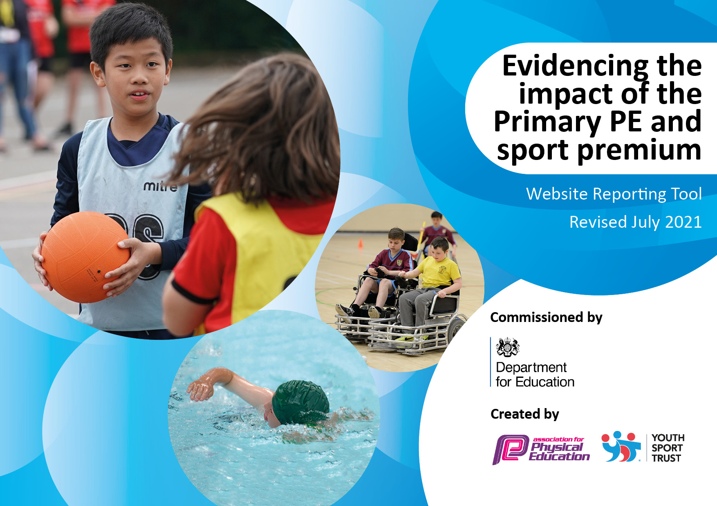
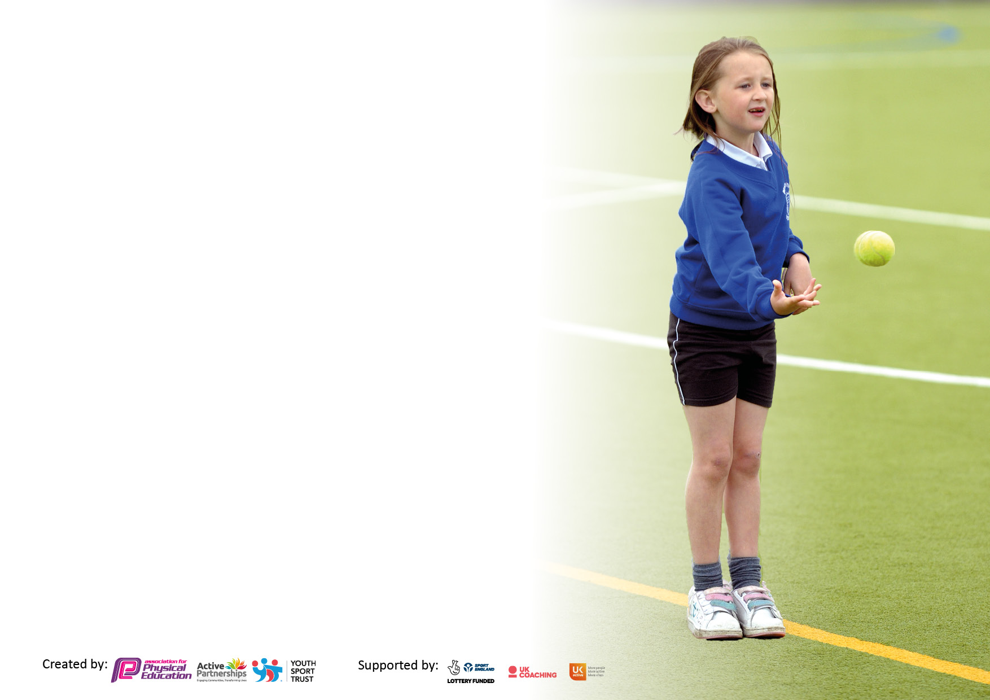

It is important that your grant is used effectively and based on school need. The Education Inspection Framework makes clear there will be a focus on ‘whether leaders and those responsible for governors all understand their respective roles and perform these in a way that enhances the effectiveness of the school’.

Under the Quality of Education Ofsted inspectors consider:
Intent - Curriculum design, coverage and appropriateness
Implementation - Curriculum delivery, Teaching (pedagogy) and Assessment
Impact - Attainment and progress

To assist schools with common transferable language this template has been developed to utilise the same three headings which should make your plans easily transferable between working documents.

Schools must use the funding to make additional and sustainable improvements to the quality of Physical Education, School Sport and Physical Activity (PESSPA) they offer. This means that you should use the Primary PE and sport premium to:

- Develop or add to the PESSPA activities that your school already offer
- Build capacity and capability within the school to ensure that improvements made now will benefit pupils joining the school in future years
- The Primary PE and sport premium should not be used to fund capital spend projects; the school’s budget should fund these.

Pleasevisitgov.ukfortherevisedDfEguidanceincludingthe5keyindicatorsacrosswhichschoolsshoulddemonstrate animprovement.Thisdocumentwillhelpyoutoreviewyourprovisionandtoreportyourspend.DfEencouragesschools to use this template as an effective way of meeting the reporting requirements of the Primary PE and sport premium.

We recommend you start by reflecting on the impact of current provision and reviewing the previous spend.

Schools are required to publish details of how they spend this funding, including any under-spend from 2019/2020, as well as on the impact it has on pupils’ PE and sport participation and attainment. All funding must be spent by 31st July 2022.

We recommend regularly updating the table and publishing it on your website throughout the year. This evidences your ongoing self-evaluation of how you are using the funding to secure maximum, sustainable impact. Final copy must be posted on your website by the end of the academic year and no later than the 31st July 2021. To see an example of how to complete the table please click HERE.

Details with regard to funding
Please complete the table below.

Total amount carried over from 2021/22 | £0
Total amount allocated for 2021/22 | £19,430
How much (if any) do you intend to carry over from this total fund into 2022/23? | £0
Total amount allocated for 2022/23 | £19,560
Total amount of funding for 2021/22. To be spent and reported on by 31st July 2022. | £0
Swimming Data
Please report on your Swimming Data below.

Meeting national curriculum requirements for swimming and water safety.

N.B. Complete this section to your best ability. For example you might have practised safe self-rescue techniques on dry land which you can then transfer to the pool when school swimming restarts.
Due to exceptional circumstances priority should be given to ensuring that pupils can perform safe self rescue even if they do not fully meet the first two requirements of the NC programme of study
What percentage of your current Year 6 cohort swim competently, confidently and proficiently over a distance of at least 25 metres?  N.B. Even though your pupils may swim in another year please report on their attainment on leaving primary school at the end of the summer term 2022  Please see note above | 10%
What percentage of your current Year 6 cohort use a range of strokes effectively [for example, front crawl, backstroke and breaststroke]?  Please see note above | 33%
What percentage of your current Year 6 cohort perform safe self-rescue in different water-based situations? | 83%
Schools can choose to use the Primary PE and sport premium to provide additional provision for swimming but this must be for activity over and above the national curriculum requirements. Have you used it in this way? | Yes/No

Action Plan and Budget Tracking
Capture your intended annual spend against the 5 key indicators. Clarify the success criteria and evidence of impact that you intend to measure to evaluate for pupils today and for the future.

Academic Year: 2022/23 | Total fund allocated: | Date Updated:
Key indicator 1: The engagement of all pupils in regular physical activity – Chief Medical Officers guidelines recommend that primary school pupils undertake at least 30 minutes of physical activity a day in school |  |  |  | Percentage of total allocation:
 |  |  |  | 5%
Intent | Implementation |  | Impact/evidence
Your school focus should be clear what you want the pupils to know and be able to do and about  what they need to learn and to  consolidate through practice: | Make sure your actions to achieve are linked to your intentions: | Funding allocated: | Evidence of impact: what do pupils now know and what can they now do? What has changed?: | Sustainability and suggested next steps:
To provide all pupils with the opportunity to engage in competitive and non-competitive sports during break times and lunch times. | Sports ambassadors to receive training to lead a wide variety of sports based activities at break times and lunchtimes.  To clarify the distinction between break time/lunch time equipment and PE lesson equipment  Updated timetable for the new academic year.  New break time/ lunch time equipment ordered | £0  £0  £0  £520 | Learning walk by subject leader.  Regular meetings between subject leader and sports ambassadors to monitor progress.  Resources are organised and correct.  Updated timetable.
To increase the sporting opportunities of pupil premium children and children who may face barriers to engagement | After school club focused around inclusive sports  Opportunities to compete in inclusive sports competitions.  Opportunities to attend events which focus around increasing sports participation for example the this girl can festival. | £1000  £100 | After school club register  Pupil voice
To encourage all pupils to engage in physical activity as part of their journey to school | Continue to implement the WOW programme (living streets)  Ensure all new members of staff are trained and competent in using the walk to school tracker.  Raise awareness of WOW programme with parents/ carers through regular posts of social media | £0  £0  £0 | WOW tracker should show increased levels of activity  Social media posts
To increase children’s skills and access to swimming | Provide all children from years 4- 6 with the opportunity to extend their swimming skills.  Develop further sessions for those not reaching 25 metres | £1295.00- swimming for 4-6  £500 | Register  % of children who have reached 25 metres  Self-rescue assessments
Key indicator 2: The profile of PESSPA being raised across the school as a tool for whole school improvement |  |  |  | Percentage of total allocation:
 |  |  |  | 6.5%
Intent | Implementation |  | Impact/ evidence
Your school focus should be clear what you want the pupils to know and be able to do and about  what they need to learn and to  consolidate through practice: | Make sure your actions to achieve are linked to your intentions: | Funding allocated: | Evidence of impact: what do pupils now know and what can they now do? What has changed?: | Sustainability and suggested next steps:
To ensure all pupils have an understanding of the benefits of leading a healthy and active lifestyle. | Sports ambassadors to deliver 3 healthy lifestyle assemblies a year.  Healthy breakfast club where children are taught how to make a healthy breakfast and the benefits of healthy eating.  Daily mile to be completed throughout the week. A daily mile register to monitor success. Classes which have reached milestones to receive a reward  Celebrate mental health awareness week by leading activities which link physical activity and mental health | £0  £100  £0  £0 | Pupil voice  Registers from healthy breakfast club  Daily mile register
To continue to raise the profile of PE throughout school and with parents/carers | Sports achievement assemblies to run every half term to celebrate sporting achievements both in school and out of school.  The introduction of badges to celebrate representing their school in sporting competitions.  Regular social media posts to celebrate sports achievements | £50- medals/trophies/ badges  £0 | Social media posts.  Pictures of pupils participating in sports.

Key indicator 3: Increased confidence, knowledge and skills of all staff in teaching PE and sport |  |  |  | Percentage of total allocation:
 |  |  |  | 1.8%
Intent | Implementation |  | Impact
Your school focus should be clear | Make sure your actions to | Funding | Evidence of impact: what do | Sustainability and suggested
what you want the pupils to know | achieve are linked to your | allocated: | pupils now know and what | next steps:
and be able to do and about | intentions: |  | can they now do? What has
what they need to learn and to |  |  | changed?:
consolidate through practice:
To give staff the skills and confidence to deliver PE lessons. | Subject leader to attend CPD and feedback to colleagues.  Subject leader to send out colleague questionnaire to identify an area for development.  Sports leaders to support the teaching of PE and upskill teachers  Subject leader and sports leaders to lead CPD to improve colleague confidence.  Sports leaders to observe outstanding practice at another LEAD school  SLT and subject leader to have coaching conversations with sports leaders to identify targets. | £300- CPD and class cover  £0  £12,000- Sports leaders  £0  £0 | Questionnaire issued after CPD to monitor progress.  Feedback session for colleagues to share their progress.  Regular learning walks
Key indicator 4: Broader experience of a range of sports and activities offered to all pupils |  |  |  | Percentage of total allocation:
 |  |  |  | 8.4%
Intent | Implementation |  | Impact
Your school focus should be clear | Make sure your actions to | Funding | Evidence of impact: what do | Sustainability and suggested
what you want the pupils to know | achieve are linked to your | allocated: | pupils now know and what | next steps:
and be able to do and about | intentions: |  | can they now do? What has
what they need to learn and to |  |  | changed?:
consolidate through practice:  To further develop new in school techniques to improve children’s experiences of outdoor and adventurous activities | To give year 2, 4 and 6 children the opportunity to engage in outdoor adventurous activities on residential.  Pupils to have a variety of different outdoor experiences through bush craft day. | £1500 | Pupil voice  Increased attendance  Social media posts regarding residential trips and outdoor experiences.
To run a wide, variety of sporting extra-curricular activities | To ensure all children have access to wide range of sporting clubs.  To begin to work with outside providers to provide outstanding sporting after school clubs.  Sporting clubs to correspond with upcoming sports competitions to give pupils to opportunity to compete in that sport.  To provide inclusive sports clubs like kurling. | £1000 | Pupil voice.  Increased participation in sports clubs.  Registers from afterschool clubs.  Achievements in sporting competitions.

Key indicator 5: Increased participation in competitive sport |  |  |  | Percentage of total allocation:
 |  |  |  | %
Intent | Implementation |  | Impact
Your school focus should be clear | Make sure your actions to | Funding | Evidence of impact: what do | Sustainability and suggested
what you want the pupils to know | achieve are linked to your | allocated: | pupils now know and what | next steps:
and be able to do and about | intentions: |  | can they now do? What has
what they need to learn and to |  |  | changed?:
consolidate through practice:
To continue to develop our schools current intra school competition programme. | Review and develop sports day  Run break time/ lunch time sports clubs daily  Introduce a winter sports festival | £45- sports day | Pupil voice  Social media posts regarding sports events  Pictures from sports events
To continue to develop our schools existing inter school competition calendar | Continue to develop our partnership with Windmill and Sycamore  Increase the range of sports that children compete in | £1000- travel costs | Pupil voice  Competition achievements  Pictures from events
To begin to attend more inclusive competitions. | Collaborate with Windmill and Sycamore to host an inclusive tournament  Attend participation events like this girl can for example | £150 | Pupil voice  Competition achievements  Pictures from events

Signed off by
Head Teacher:
Date: | 24.06.2022
Subject Leader: | P Lees-Collier
Date:
Governor:
Date:

