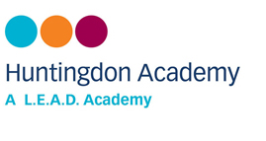
Safeguarding Newsletter

Term 1 2023

Welcome!

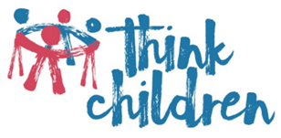
Welcome to Huntingdon Academy’s first Safeguarding Newsletter of 2023. Keeping children safe is of course, a key priority in school. Safeguarding takes many forms including: protecting children from harm; preventing impairment of children’s health and development; enabling safe and effective parenting and giving children equal opportunities in life. We do many things every day in school to ensure pupils are safe including: ensuring all staff are trained in safeguarding; having clear policies and procedures in place to keep children safe; monitoring pupil attendance; ensuring a safe and healthy site; ensuring the behaviour of pupils is in line with the Academy behaviour policy and using our curriculum to teach children about risk taking, diversity, healthy lifestyles, managing relationships, online safety and much more. Our safeguarding policy is always available via our website.
In school Think Children work with children
struggling to cope with a wide range of issues such as relationship difficulties, parental separation, bullying, bereavement, domestic violence and low self-esteem. Each child is offered one-to-one sessions that enable them to use the imaginary world of play to release pent-up emotions, clarify how they see their situation and move on with new coping skills. Please see class teacher.

Mental Health Support accessible in or through school:

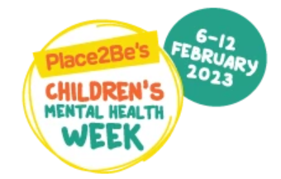

Mental Health Support Team (MHST)
Huntingdon is a Mental Health Support Team School (MHST) This have been developed to increase earlier access to support with mental health and wellbeing, they are based in school one day a week to help children access support and help to increase a whole school approach to mental health wellbeing. A Educational Mental Health Practitioner is based in the school one day a week and work closely with Louise Yarnell the mental health lead to ensure that the mental health needs within the school are identified and bespoke interventions offered.
MHST offer interventions that have been shown to help support children and young people overcome difficulties with their mental health and wellbeing. These may be offered on a 1-1 basis or with parents/caregivers.The majority of our interventions use Cognitive Behavioural Therapy approaches.

Children’s Mental Health Week 2023 will take place from 6-12 February 2023. This year’s theme is Let’s Connect.
Human beings thrive in communities, and this connection is vital for our wellbeing, and our survival. When we have healthy connections – to family, friends and others – this can support our mental health and our sense of wellbeing. And when our need for rewarding social connections is not met, we can sometimes feel isolated and lonely – which can have a negative impact on our mental health.
Targeted CAMHS (children and adolescent mental health services)
Who is this for? Children and young people with moderate emotional and/or mental health needs.
What do they offer? You’ll be able talk openly about the difficulties that you’re experiencing and explore choices for support. CAMHS will help determine what options may be helpful, discuss and plan together with you and your family. CAMHS offer a range of evidence based, therapeutic interventions.
Phone: 0115 876 4000 Text: 0786 000 213 Email:cypbehm@nottinghamcity.gov.uk
Alternatively you can speak to your child’s teacher.

Let's Connect is about making meaningful connections for all, during Children's Mental Health Week - and beyond.

Safeguarding Newsletter

Who can help?

Every school has a ‘Designated Safeguarding Lead’. At Huntingdon Academy, this is Miss Yarnell,
Mr Middleton, Mrs Riley and Mrs Vaughan.
Our Safeguarding governor is Mrs Ros Murphy.

If you have any concerns in relation to safeguarding, please feel free to speak to Miss Yarnell,
Mr Middleton, Mrs Want or Mrs Riley.

Useful phone numbers

Children and Families Direct: 0115 876 4800

ChildLine: 0800 1111

Nottingham Prevent Team: call 101 ext. 800 2963/2965 or ask to speak to the Prevent Team.

Carers Federation, Action for Young Carers project:
0115 962 9351

NSPCC whistle blowing helpline: 0800 028 0285

FGM helpline: 08000 283550

Samaritans: 0115 941 1111

Mental Health Helplines

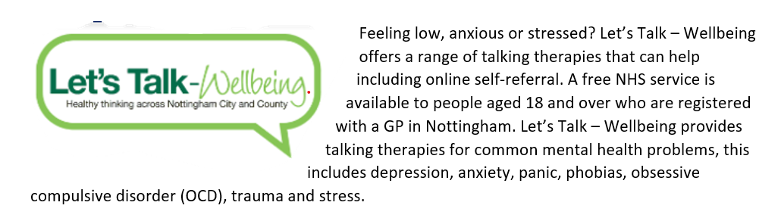
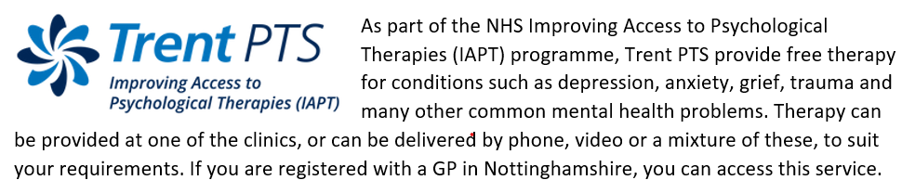
MIND 0300 123 3393 Weekday 9am – 6pm
Mind provides advice and support on a range of topics including mental health problems.
RMI 0808 801 0525 weekdays 9:30am-4pm
Rethink Mental Illness advice offers practical help and information for anyone affected by mental illness
SANE 0300 304 7000 daily 4:30pm- 5.30pm
SANE provides confidential emotional support and information to anyone affected by mental illness
THE MIX 0808 808 4994 daily 3pm-12am
The Mix provide support for young people under 25 on a variety of issues including Mental Health, sex and relationships
PANDAS 0808 1961 776 daily 11am-10pm
Pre and Postnatal Depression Advice and Support offers support to families suffering from pre and postnatal illnesses

